## Engagement Agreement

Agreement for Healing Services between and Ellie Pechet, M.Ed. Metaphysician

Single Session Amethyst Package (4) Emerald Package (8) Phoenix Package (12)

#### Confidentiality

Identifying material that surfaces during session work is held in strict confidence.

#### Scheduling

Appointments are scheduled in advance. Please call (508) 237-4929 to schedule your appointment.

#### Payment

Packages are recommended for more results and savings. Visa/Mastercard, cash or check accepted.

#### Cancellation Policy

Rescheduling must be done by phone with at least 48 hours notice. No refunds issued.

I have read and understand the above policies and procedures. I agree to uphold them, and indicate my consent with my signature and my payment.

Payment: Date: Signed:

## Ellie Pechet, M.Ed. (508) 237- 4929

[**www.PhoenixRisingHealing.com**](http://www.PhoenixRisingHealing.com/)

#### Orange County, CA

**Phoenix Rising Intuitive Counseling & Energy Healing LLC**

## About Ellie

**Ellie Pechet, M.Ed.** is a highly trained & naturally gifted Metaphysician, Medium, Shaman and Author. She has a master’s degree in counseling from Cambridge College. Her private practice is a combination of highly intuitive counseling and her own technique developed over 33 years of experience. The Pechet Healing Technique is one of the most advanced, efficient healing techniques on the planet.

##### *** IN PERSON & LONG DISTANCE ***

Ellie was a 2-time keynote speaker at the Afterlife Conference in Scottsdale, AZ. There she talked about her cutting edge book, "Hitching A Ride" which features her abilities as a Shaman, removing destructive energy attachments from some of her clients over the past 17+ years. Available on website.

Ellie uses her **Pechet Healing Technique** to energetically dissolve deep-rooted, emotional and physical issues for her clients all over the world, by phone and Skype, She also sees clients locally in her Orange County, CA location. Some of the issues Ellie permanently resolves for her clients include **depression, grief, PSTD, anxiety, insomnia, chronic pain,** and many other physical symptoms and conditions including Covid-19.

##### Ellie's ability to literally dissolve a core issue every session *for good* is what sets her apart from other healers, practitioners, and therapists.

*Medical issues take more than 1 Session.

###### Call Now and Experience Immediate Results.

**Free from Depression & Insomnia**

**"I am amazed at how you can sense things from a distance..I definitely feel a difference:lighter, calmer, and more peaceful as a result of our work and best of all, the depression & insomnia are gone!"**

**- Peter Wardell, Scientist, Springfield, MA**

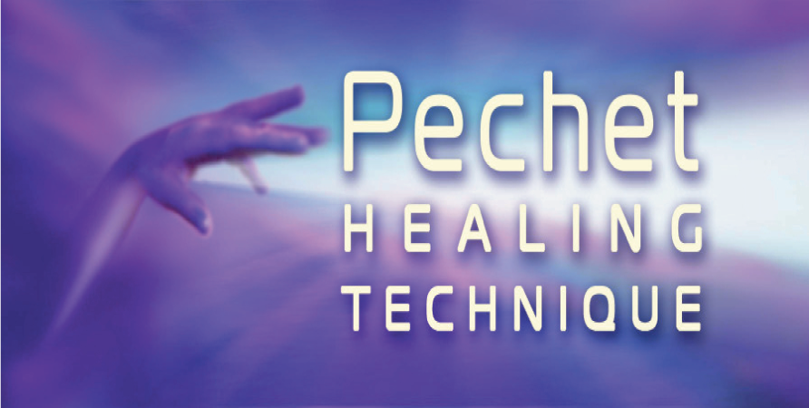

**EXPECT A MIRACLE**

# Wherever You Are

Emotional and physical issues permanently healed for people and pets.

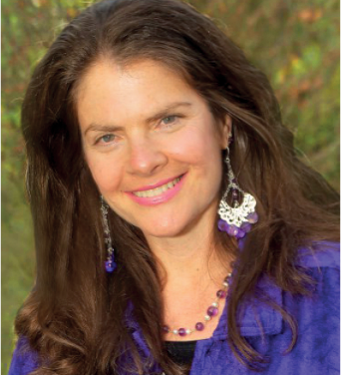

**Ellie Pechet, M.Ed.**

Metaphysician ♦ Shaman ♦ Author

**Call for Remote Healing Sessions:**

**(508) 237- 4929**

[**www.PhoenixRisingHealing.com**](http://www.PhoenixRisingHealing.com/)

[PhoenixRisingHealing@gmail.com](mailto:PhoenixRisingHealing@gmail.com) Skype: ellie.pechet

33 Years Experience

**Permanent results every session**

## Introduction Testimonials Plans

#### Are you ready to resolve issues that have not responded to other modalities?

* I will permanently heal issues for you such as grief, anxiety, depression, trauma, chronic pain, insomnia, chronic pain, viruses, and most physical conditions.
* You will enjoy an increased ability to manage your life with greater balance and effectiveness and most of all, profound inner peace**.**

Access profound, immediate results that last from anywhere in the world, with Ellie over the phone, by Skype or Zoom, or in person.

## Services

### Distance Healing

#### I resolve emotional issues & physical conditions at the deepest level possible.

**Advanced Energy Clearing Sessions**

* Experience profound inner peace as I reduce and eliminate a core emotional or physical issue for you every session. Results last.
* Eliminate emotional issues as they come up in current circumstances, such as your job, relocation, relationships, loss of a loved one...

### Intuitive Health Scan

* Intuitive scan to identify energy blocks and

pain symptoms in the body.

* Chronic and acute pain areas and imbalances are identified and a plan of action is made to reduce symptoms & issues.

“ELLIE IS ONE OF THE GREAT HEALERS ALIVE ON THE PLANET TODAY.”

*Berny Dohrmann, Founder, CEO Space*

#### First Session

“I feel so relieved! The pain is not there anymore! Your work is amazing!!”

—Diane Fountain, 84 Yrs Old, Phoenix, AZ

#### Special Gift

“Ellie has a special gift. I would highly recommend her to anyone, especially for her intuitive counseling and energy work”

—Donna Rigollizo, M.D. Psychiatrist, Cape Cod

#### The Real Deal

“I’ve received energy healing before, and it was nothing like this. It is a delightful surprise that Ellie has been able to touch me so deeply. After my sessions, I feel lighter, like a literal weight has been lifted. Ellie is definitely the REAL DEAL.”

—Scout Tomyris, Santa Rosa, CA

**Effective With Pets**

“I have never seen results like Ellie gets with the pets she works with. Her work is really amazing.”

--Dana Dvorak, Animal Communicator

#### Cancer Relief

“Weeks after being diagnosed with cancer, I was filled with anxiety and unable to sleep. After Ellie’s long distance, deep clearing work, my anxiety was gone and I was no longer in fear of my diagnosis. I was able to sleep. The well-being I experienced continued well beyond each session. Ellie’s gentleness as a healer and her ability to intuit and heal long distance have made me a grateful believer.”

—Marie Ballard, Cape Cod, MA.

## Pechet Healing Technique

**Call Now: (508) 237- 4929**

*Each successive package offers sessions at a bigger discount for you.*

#### Your Biggest Issue Resolved

Clarify your issues and experience the power of the Pechet Healing Technique. **1** issue healed for good. Move closer to your authentic self starting with your first session

(Medical issues take more than 1 session.)

#### Amethyst Package

Strengthen your energetic core by eliminating **4** Issues at the cellular level. You will notice that the *cumulative impact of these four sessions* results in greater inner peace so you can start living your life the way you want to.

#### Emerald Package

For the individual committed to an even higher level of healing and personal transformation, **8** issues eliminated at the cellular level. This package is well suited if you have long term emotional issues and physical health concerns.

#### Phoenix Package

Eliminate **12** issues for good. The cumulative impact of these sessions will bring you into alignment with your authentic self and profound on going inner peace.

Share sessions with your spouse and family members.

**It’s Your Turn**

Your investment in your healing is minimal compared to what you pay for doctor visits, prescriptions and especially downtime due to lack of health. My clients are loving their lives now because they are well. Experience profound healing and complete wellness on every level.

**Visit PhoenixRisingHealing.com**